Issues worth our attention:
- Duplicate Potential Problem:

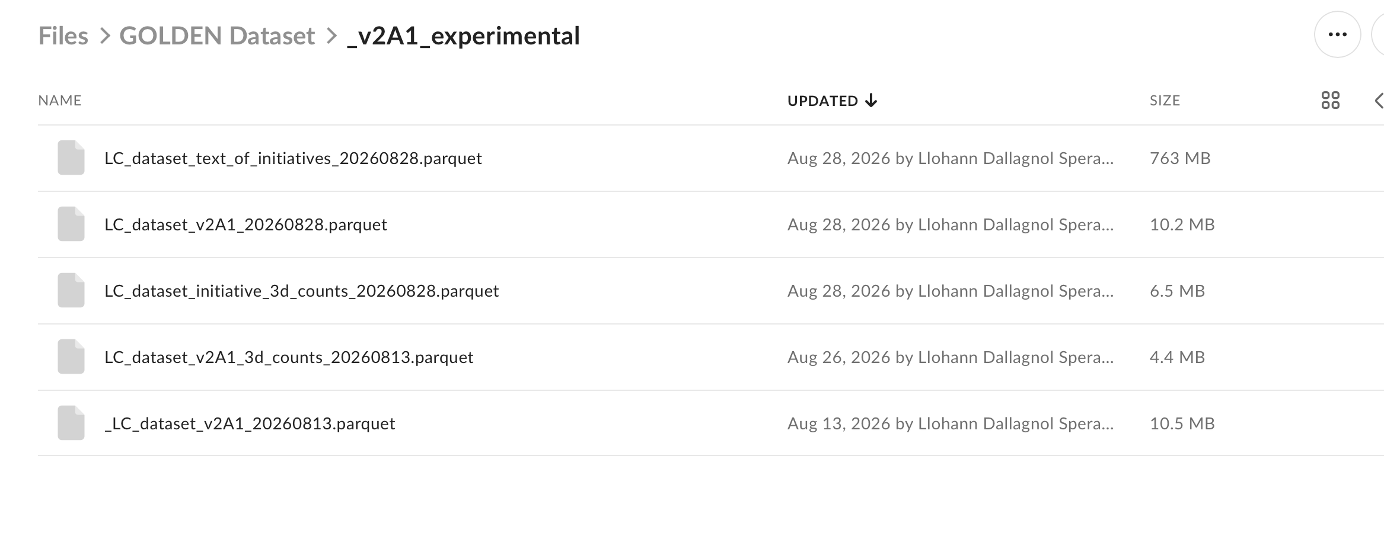

- Min initiatives when observing materiality.


- The code has no minimum group size before allowing for a z-score normalisation. If there is a group of 5, then the z-score would be statistically poor. Especially when n = 1, we get a z-score of infinity. N= 30 is recommended.

Limitations:

- Alpha bound trim:

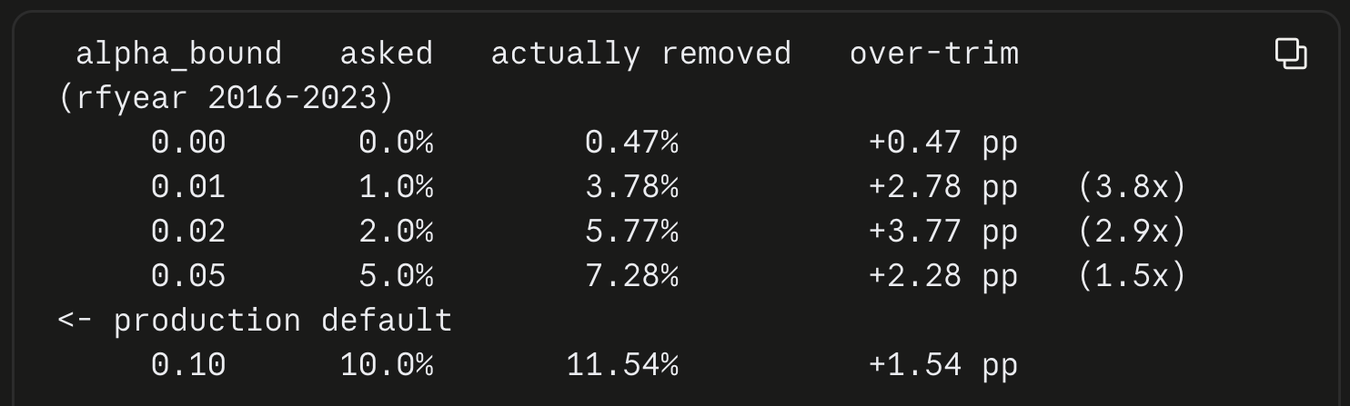
- HC1 in Factor regression

